|  |  |
| --- | --- |
|  | **[Design & Analysis of Algorithm]**  **[BSCS – 5 A]**  **Department of Computer Science**  **Bahria University, Lahore Campus** |

**Solution Assignment: 2** Date: Week [5], ____ [Oct 2023**]**

Name: Muhammad Haris Yasir Roll No: 03-134212-062

|  |  |  |  |
| --- | --- | --- | --- |
| **Evaluation of CLO** | **Question Number** | **Marks** | **Obtained Marks** |
| **CLO1: CLO statement**  **CLO1:** Analyze algorithm (estimate upper and lower bounds without coding and running the algorithm)  **CLO3.** Apply correctness, and complexity analysis techniques | 1 | 2.5 |  |
| **Total Marks** | | **2.5** |  |

**Q1. Solve following recurrence using substitution method.**

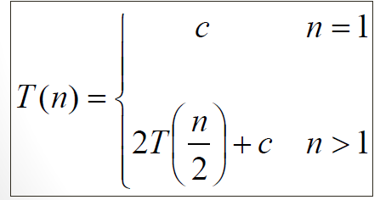

**Q2. Solve following recurrence using recursion tree method.**



